Continuing Portfolio Selection

Solving systems of linear equations with two variables (SLETV) has solution that is a point rather than a feasible region. You solve both by translating the situation into an equation or inequality using x and y and then creating a graph. SLETV graphs just have lines instead feasible regions. The solution is the point where the lines cross or intersect. There's one answer.

For example in "Going Out to Lunch" we knew 23 people bought a hamburger or a hot dog. Turned into an equation, that's x + y = 23. And we knew the total was $32.10 for the $1.50 hamburgers and the $1.10 hotdogs. That can be translated into the equation 1.50 + 1.10 = 32.10. When you graph those two lines on the same axis, they intersect at (17, 6). So there were 17 hamburgers (X) ordered and 6 hotdogs (y) ordered.

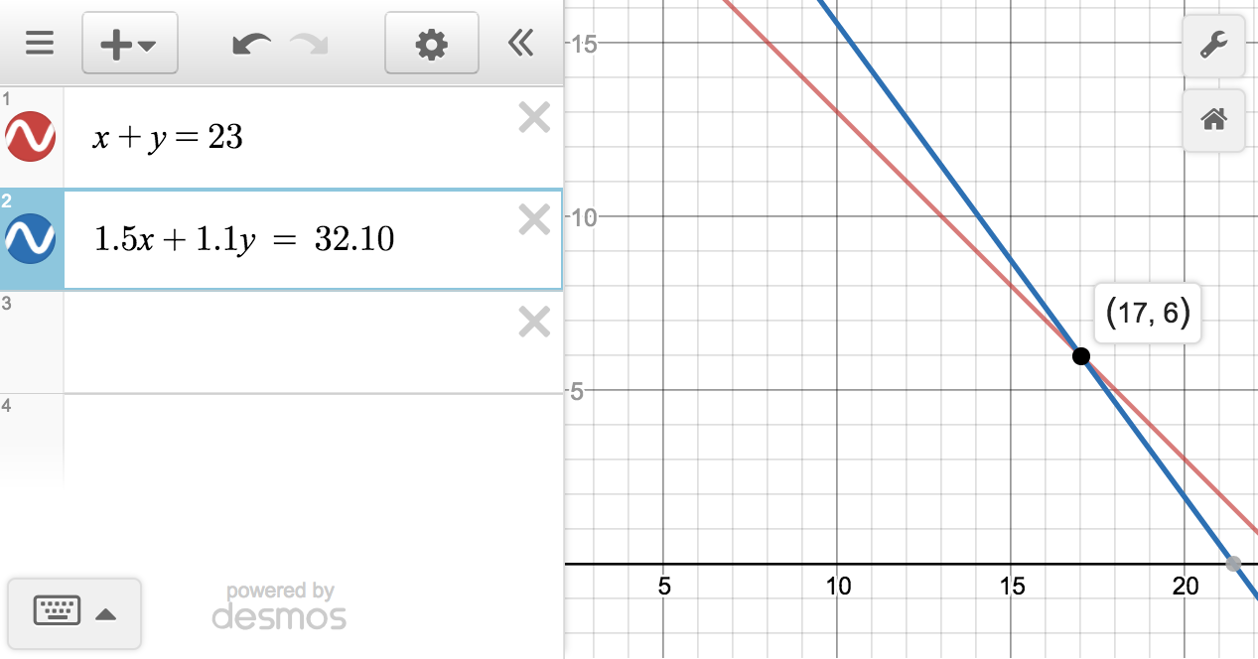

Another example is

