Math Skills 9/11/17 Name:

Directions: Solve the following problems. Leave questions, notes, computations, sketches or other information that will help you explain how you got your answer.

- Gwen is driving at a speed of 50 miles per hour. At 2:00 she sees the following sign.

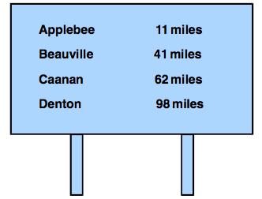
Gwen continues at the same speed. At 2:30 how far from Caanan will she be?
  - 12 miles
  - 16 miles
  - 25 miles
  - 26 miles
  - 37 miles

- Max spent the day bird watching and counted 34 more birds in the morning than in the afternoon. If he counted a total of 76 birds, how many birds did he count in the afternoon?
  - 21 birds
  - 40 birds
  - 42 birds
  - 84 birds
  - 110 birds

- Mrs. Oakley has 10 pencils,. She needs a fifth of that amount for class. How many pencils does she need for one class?

Math Skills 9/11/17 Name:

- Directions: Read the information below; then answer the question that follows. Which of the following facts can be determined from the information given above?
A refrigerator in a school cafeteria is partially filled with 42 sandwiches. There are 13 turkey sandwiches, 14 cheese sandwiches, and 15 egg salad sandwiches. By the end of the lunch period, 21 of the sandwiches have been sold.

  - the number of cheese sandwiches sold
  - the cost of a turkey sandwich
  - the total number of sandwiches that can be placed in the refrigerator
  - the total dollar sales of sandwiches during the lunch period
  - the number of sandwiches remaining in the refrigerator after the lunch period

- Read the problem below; then answer the question that follows. Which single piece of information is necessary to solve the problem above?

Wei-Jen and Sue are going to drive cross country. To reach their destination, they plan to drive about 400 miles each day for 5 days. If gasoline costs an average of $2.00 per gallon, approximately how much money should they budget for gasoline on this trip?

  - the number of times they will have to stop for gasoline
  - the number of miles the car travels per gallon of gasoline
  - the number of miles Wei-Jen will drive
  - the total distance of their trip
  - the number of miles the car travels per hour

- If Caroline gives her horse two carrots a day, how many carrots would she give the horse in five weeks?

