Directions: Solve the following problems. Leave questions, notes, computations, sketches or other information that will help you explain how you got your answer.

Use the diagram below to answer the question that follows.
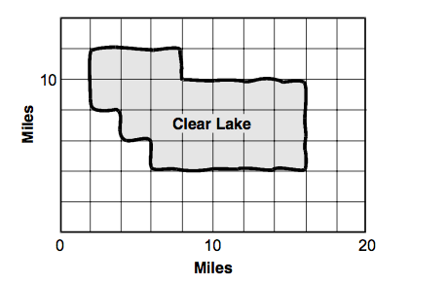
What is the total length of Clear Lake's shoreline?
- 22 miles
- 44 miles
- 48 miles
- 56 miles
- 84 miles

2. Caroline hugs 4 puppies every 3 days. Approximately how many puppies does she hug per month?

- 4 puppies
- 12 puppies
- 25 puppies
- 40 puppies
- 1,000,000 puppies

