Math Skills 9/7/17 Name:

Directions: Solve the following problems. Leave questions, notes, computations, sketches or other information that will help you explain how you got your answer.

- Mr. Christensen has three packages of stickers. One package contains 56 stickers, another package contains 48 stickers, and the third package contains 58 stickers. If the teacher divides all the stickers equally among 27 students, how many stickers will each student receive?
  - 6 stickers
  - 9 stickers
  - 54 stickers
  - 81 stickers
  - 162 stickers

Math Skills 9/7/17 Name:

Directions: Solve the following problems. Leave questions, notes, computations, sketches or other information that will help you explain how you got your answer.

- Use the information below to answer the question that follows. As part of a unit on weather, students recorded the outdoor temperature at 8:30 A.M. for five mornings. What was the difference between the week's highest and lowest morning temperatures?
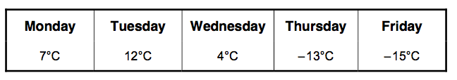
  - – 3°C
  - – 1°C
  - 8°C
  - 22°C
  - 27°C

Math Skills 9/7/17 Name:

Directions: Solve the following problems. Leave questions, notes, computations, sketches or other information that will help you explain how you got your answer.

- 3. Use the diagram below to answer the question that follows.
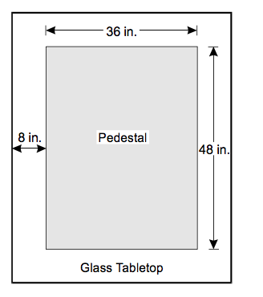
  - Brandon’s glass tabletop is supported by a rectangular pedestal. If the tabletop is 8 inches wider than the pedestal on each side, what is the perimeter of the glass tabletop?
  - 92 inches
  - 116 inches
  - 176 inches
  - 184 inches
  - 232 inches

Math Skills 9/7/17 Name:

Directions: Solve the following problems. Leave questions, notes, computations, sketches or other information that will help you explain how you got your answer.

- At the beginning of a class period, half of the students in a class go to the library. Later in the period, half of the remaining students go to the computer lab. If there are 8 students remaining in the class, how many students were originally in the class?
  - 12 students
  - 16 students
  - 24 students
  - 32 students
  - 40 students

Math Skills 9/7/17 Name:

Directions: Solve the following problems. Leave questions, notes, computations, sketches or other information that will help you explain how you got your answer.

- Teagan works 38 hours per week and earns $7.25 per hour. Her employer gives her a raise that increases her weekly gross pay to $307.80. What is the increase in Teagan's weekly gross pay?
  - $ 32.30
  - $ 34.70
  - $ 42.46
  - $ 275.50
  - $ 300.55

