Amount of Dough: P+0.7I < 110 = I < 157-P/.7

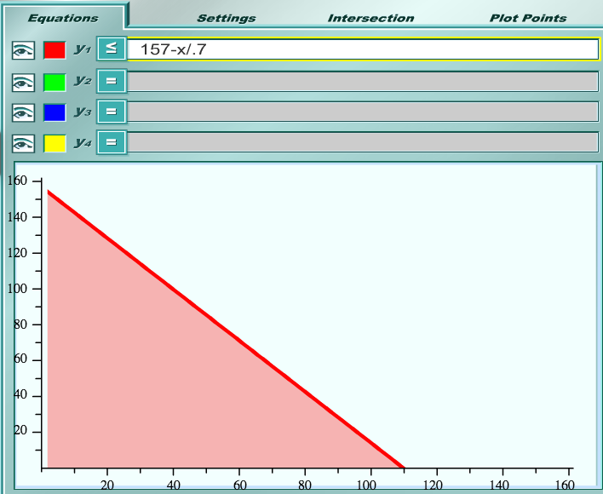

Icing: 0.4I < 32 = I < 80

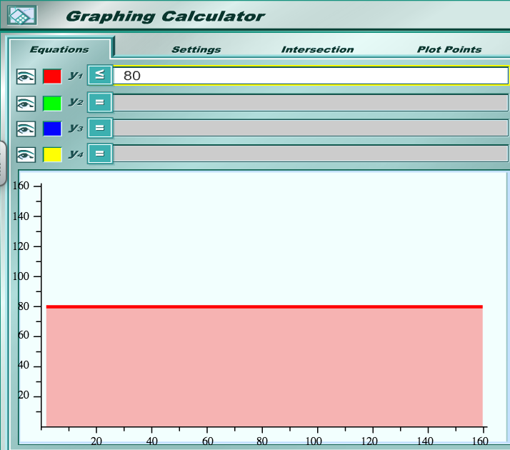

Oven Space: P+I < 140 = I < 140-P

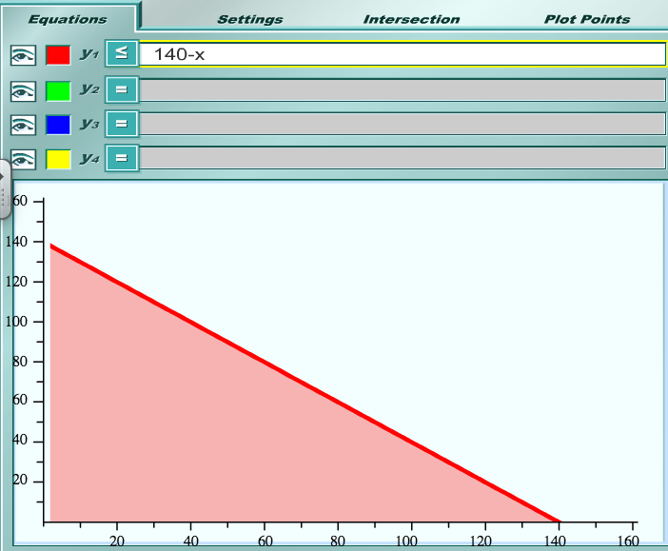

Preparation Time: 0.1P + 0.15I < 15 = I < 100 - .666P

