**A Portfolio of Formulas**

**Sketch Shape Formula Explanation**

9

12

Rectangular Prism

**Volume** is the space inside a rectangular prism

LWH = V

2(LH+LW=WH) = SA

**Surface Area** is the area of all the sides of a rectangular prism

6

**Area** is the space inside a rectangle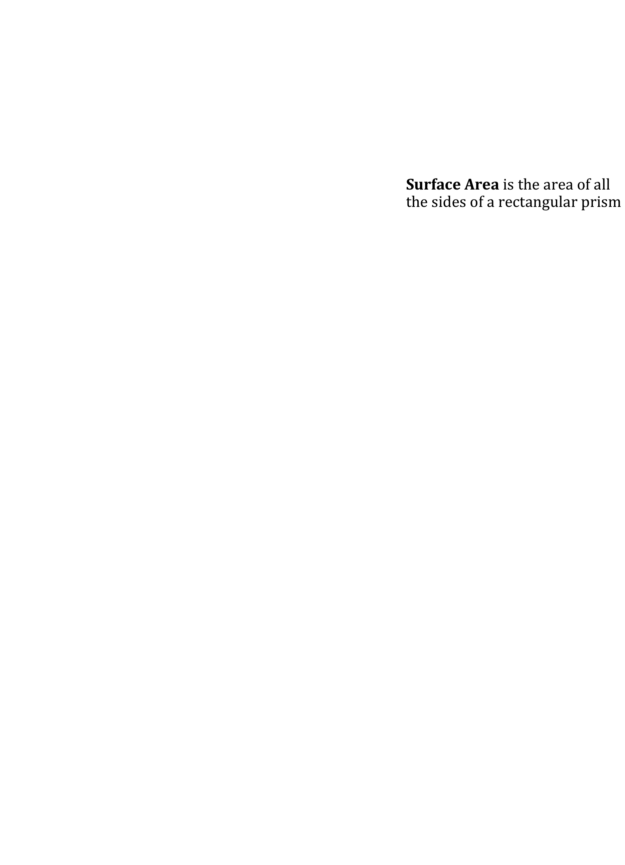

BH = A

Rectangle 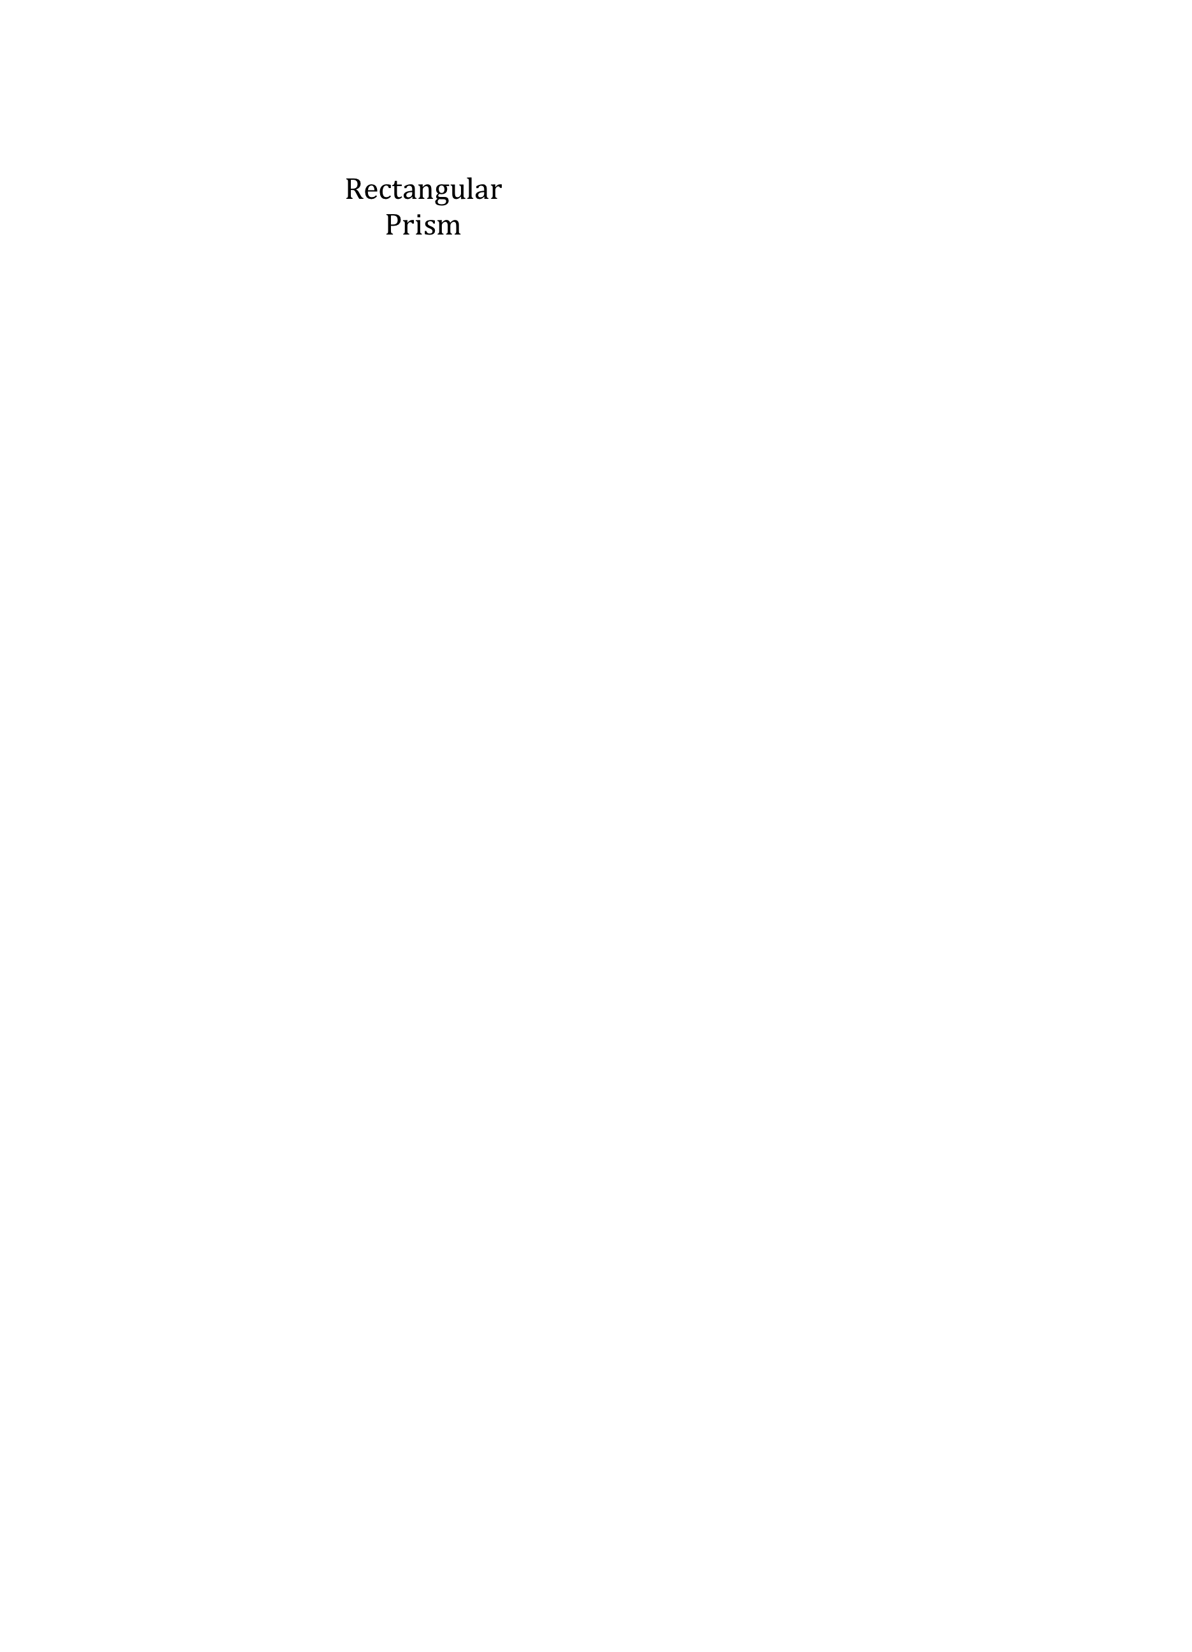Prism

6

**Perimeter** is the space around a rectangle

2B + 2H = P

8

**The Pythagorean Theorem**: for all right triangles, the shortest side squared, plus the next shortest sided squared will equal the lonest side squared

a2 + b2 = c2

Right TrianglePrism

c

b

a