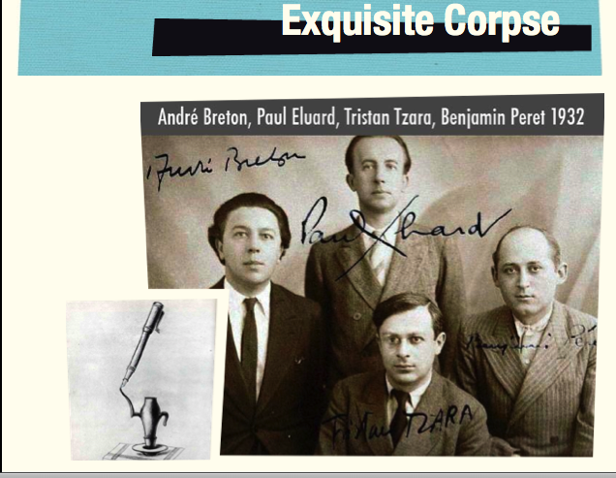
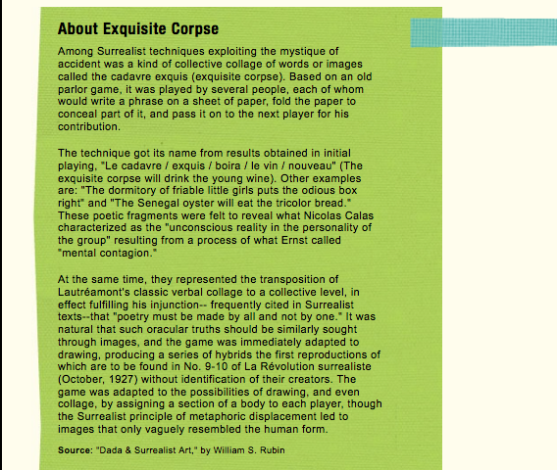



Exquisite Corpse: Taking a cue from the surrealists (see the back of the page) we will write poems together as a class. Each person will start and end a poem.
- Break into groups of eight or nine
- Each person will start a poem. Start with some line like either of the ones below. Everyone writes that line on the top of a blank page
- Each person writes a second line and folds the paper over to hide the first line.
- Pass the paper to the classmate to your right.
- He will see only the second line and write a third line.
- Then he will fold the page so the next person can see his line only.
- That person writes a fourth line, folds and passes.
- Continue until the page reaches the person who wrote the first line.
- First line writers, write the last line
- Share poems with the group
- If time allows, repeat with a new starting line. (You might choose a memorable line from one the poems shared)

Possible first lines
The snail is afraid of the stalks that hold up his eyes
or
The exquisite corpse will drink the young wine

