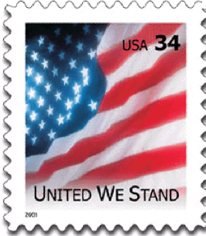
Directions: Write a postcard from an interesting place in your book to a future reader or your future self or someone who's already read the book or even from one character to another. Tell them about something important going on in the book, how the weather is, why you wish he or she was there, what's interesting or confusing about the book, what you think will happen next or anything else about your trip into the world of your book.
Place Stamp
Here

Book
Author
Page(s)
Addressee
Dear

Addressee

Book

Author

Page(s)

Directions: Write a postcard from an interesting place in your book to a future reader or your future self or someone who's already read the book or even from one character to another. Tell them about something important going on in the book, how the weather is, why you wish he or she was there, what's interesting or confusing about the book, what you think will happen next or anything else about your trip into the world of your book.

