Exponents, Negative Numbers and Parentheses Practice 1

Evaluate. PARENTHESES EXPONENT RULE: Exponents without parentheses is just for the number.

- (-2)²

- (-1)¹³

- -2²

- (-2)⁴
- (-1)⁴

- (-3)³
Evaluate. ZERO-EXPONENT RULE: Exponents of 0 equals 1 (X⁰ = 1)

- 2⁰

- -1⁰
- 4⁰

- 12⁰
- -2⁰

- (-13)⁰
Evaluate. PRODUCT RULE: To multiple exponents of the same base, keep the base and add the exponents
(X^{2 •} X³ = X⁵)

- 3^{2 •} 3³ =

- 5^{1 •} 5⁴ =
- 2^{2 •} 2³ =

- 4^{2 •} 4³ =
- 6^{2 •} 6³ =

- X^{3 •} X⁵ =

Evaluate. QUOTIENT RULE: To divide exponents of the same base, keep the base and subtract the exponents: X⁶ = X⁶⁻² ⁼ X⁴
X²

- 4⁶ =
4²

- 5⁵ =
5¹
- 2⁹ =
2⁷

- 6⁸ =
6⁵
- 8⁷ =
8⁷

- X⁴ =
X³

Exponent Terms and Rules

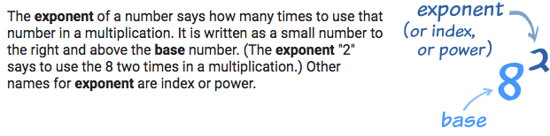
Exponential expression or Exponential form uses the exponent: 4³.

Expanded form or Distributed notation turns the exponent into a multiplication problem: 4 • 4 • 4.

Consider or Evaluate mean to solve.

Zero-Exponent Rule: a⁰ = 1, this says that anything raised to the zero power is 1.

Product Rule: a^{m} ∙ a^{n} = a^{m + n}, this says that to multiply two exponents with the same base, you keep the base and add the powers.

Quotient Rule: 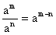, this says that to divide two exponents with the same base, you keep the base and subtract the powers.

Power Rule (Powers to Powers): (a^{m})^{n} = a^{mn}, this says that to raise a power to a power you need to multiply the exponents.

Negative Exponent Rule: 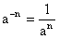, this says that negative exponents in the numerator get moved to the denominator and become positive exponents.

