Classwork: Two-minute meditation: Ryan’s choice.
Log into MathSpace at https://mathspace.co/student/ and start with #1:
- Exponent Notation 1
- Exponents Zero Power
- Exponents Power Rule
- Exponents Product Rule
Exponent Terms and Rules
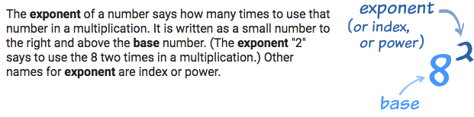
Exponential expression or Exponential form uses the exponent: 4³.

Expanded form or Distributed notation turns the exponent into a multiplication problem: 4 • 4 • 4.

Consider or Evaluate mean to solve.

Zero-Exponent Rule: a⁰ = 1, this says that anything raised to the zero power is 1.

Product Rule: a^{m} ∙ a^{n} = a^{m + n}, this says that to multiply two exponents with the same base, you keep the base and add the powers.
Quotient Rule: 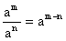, this says that to divide two exponents with the same base, you keep the base and subtract the powers.

Power Rule (Powers to Powers): (a^{m})^{n} = a^{mn}, this says that to raise a power to a power you need to multiply the exponents.
Negative Exponent Rule: 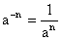, this says that negative exponents in the numerator get moved to the denominator and become positive exponents.

